INFLUENCE OF DOPING ON PHYSICAL PROPERTIES OF VITREOUS As₂Se₃

Ivan Furár (a), Viera Trnovcová (a), Dimitrij Ležal (b),

- Faculty of Materials Science and Technology, Slovak University of Technology, SK-917 24 Trnava, Slovakia
- Laboratory of Inorganic Materials, Institute of Inorganic Chemistry, Academy of Sciences of Czech Republic & Institute of Chemical Technology, 166 28 Prague, Czech Republic.

The influence of impurities (B, Al, In, Ga, Tl, Ge, Ti, Cu, Pb, U, Hg, O, H) added in different chemical forms on the Vickers microhardness, density, glass transition temperature (T_{g}), absorption edge, ac and dc conductivities, permittivity, heat capacity, thermal conductivity and thermal diffusivity of vitreous As₂Se₃ was investigated [1-4]. The impurities were added into the melt as elements and/or selenides (except oxygen which was added as As₂O₃ and SeO₂) so that it was possible to appreciate the influence of defects resulting from a disturbed stoichiometry of the glass. The influence of annealing at T_{g} on the homogeneity of doped glasses was also examined. Concentration dependences of the physical properties were studied over the whole glass-forming region but the main attention was paid to the influence of small quantities (up to 3 molar %) of impurities. The III a-group elements, IVth period elements, gettering elements, heavy metals and common impurities (O,H) were chosen as dopant.
The main experimental results are: 1) Impurities used change substantially electrical (U, Ga, Cu), dielectric (U, Tl, Ge, Cu), thermophysical (O, Ge, Tl), or mechanical (B, Hg, In) properties of vitreous As₂Se₃; both an increase and decrease of corresponding physical parameters with increasing concentration of the impurities are possible (Fig.1); 2) In, Al, Ga

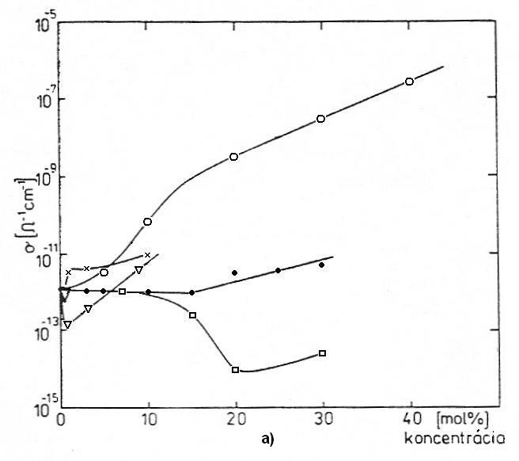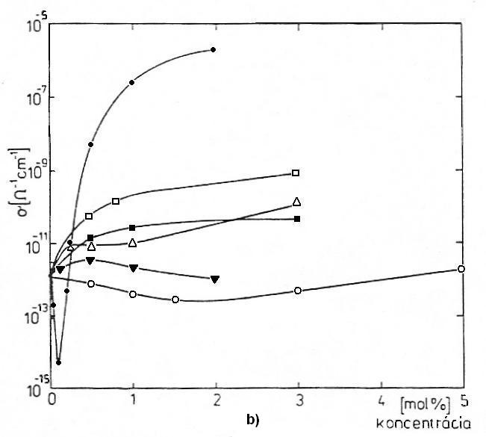
Fig. 1. Influence of impurities on the conductivity of vitreous As₂Se₃, at 300 K: a) Tl (□), Hg (●), Ge (∇), Cu (○), B (x); b) U (●), Pb (○), Ti (▼), Al (∆), In (■), Ga (□).

increase monotonously the electrical conductivity; they are probably incorporated as shallow, 4-fold coordinated acceptors; 3) heavy metals, probably incorporated in glass as 4-fold coordinated cations, bring about a distinct minimum or maximum in the concentration dependence of the electrical conductivity and activation energy, respectively; the most effective impurity is U – at 0.2 molar %, it decreases the conductivity by 10⁻³ times and the permittivity by 25 %; 4) doping with oxygen results in a distinct decrease of the density and T_{g}, already at 100 ppm, but its influence on electrical and mechanical properties is very slight; 5) the large influence of B on mechanical properties, and its slight influence on electrical properties indicate a possible 3-fold coordination of this small atom; 6) up to 10 molar %, the influence of Ge is negligible, a sudden change of physical properties at 15 molar % Ge indicates a different form of incorporation at low and high concentrations; 7) any doping does not influence the ac component of electrical conductivity which is always temperature independent; the temperature and/or concentration dependence of this component indicate a microscopic inhomogeneity of the glass; 8) a pronounced influence of annealing at T_{g} on physical properties, especially on the permittivity, occurs at doping with some elemental metals (Hg, Pb, Tl) but not at doping with selenides.

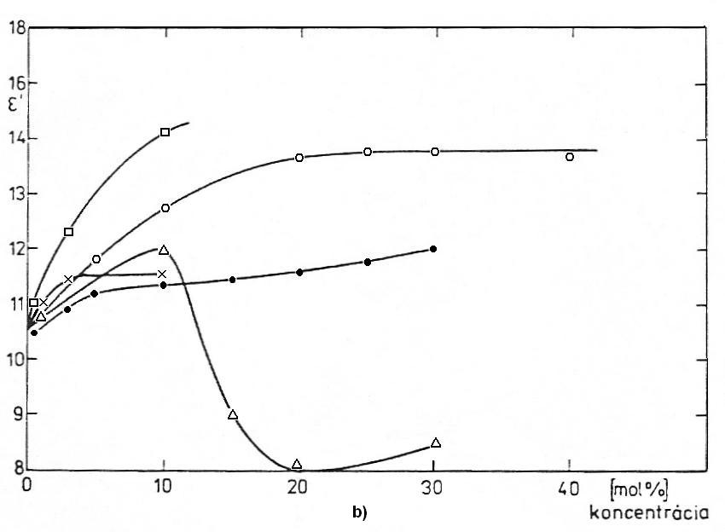
Fig. 2. Relative permitivity of As₂Se₃ doped with Ge (∆), Hg (●), B (х), Cu (○), Tl (□)

The results are discussed from the physical and technological point of view and they are explained using the KAF's theory of defects and their interaction. The best gettering element is Ti as it binds oxygen very effectively and does not influence the physical properties of As₂Se₃ glass.

References
[1] V. Trnovcová, Čs. čas. fyz. A 30 (1980) 346
[2] V. Trnovcová, M. Pavlíková, D. Ležal, E. Mariani, in: Electronic phenomena in non-crystalline semiconductors, (Kolomijec, B.T., Ed.), Nauka, Laningrad 1976, pp. 279-284
[3] V. Trnovcová, D. Ležal, E. Mariani, M. Pavlíková, in: Amorphous Semiconductors ´76 (Kósa-Somogyi, I., Ed.), Akadémiái Kiadó, Budapest 1977, pp. 133-138
[4] V. Trnovcová, D. Ležal, J. Doupovec, et al., in: Amorphous Semiconductors ´78, Vol. I, (Závětová M., Vorlíček V., Eds.), Pardubice-Praha 1978, pp. 289-294

